**Name: Trần Nguyễn Quang Vinh**

**Student Code: SE184691**

**Subject: PRF192- PFC**

**Workshop 03**

**Objectives:**

1. Practicing skills at analyzing and implementing programs using user-defined functions.
2. Making familiar with some basic algorithms

**Ex1 ( 2 marks) :** Write a C program to input radius of circle from user and find diameter, circumference and area of the given circle using function

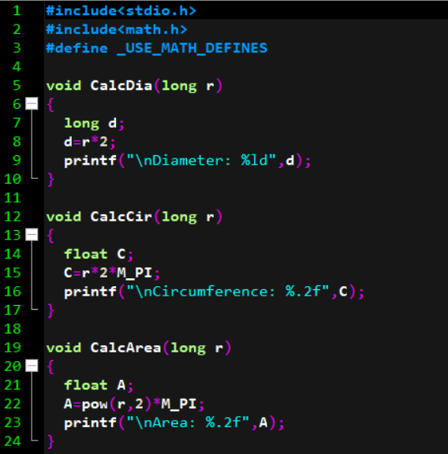

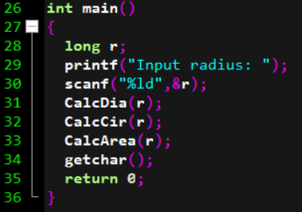

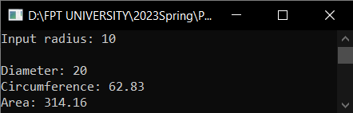

**Ex2 ( 2 marks) :** Write a function in C programming to find prime numbers using function. How to find all prime numbers between two intervals using functions.

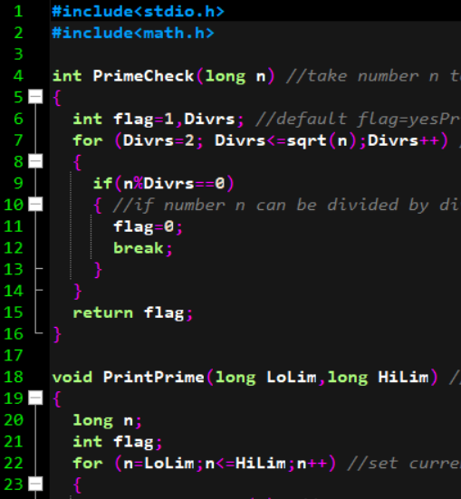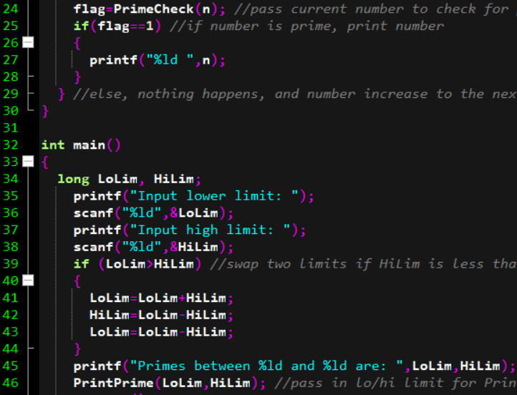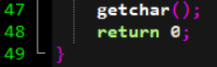

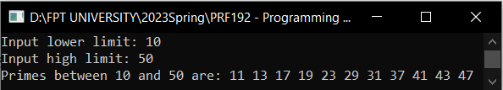

**Ex3 ( 2 marks) :** Write a function to swap 2 user-entered integers

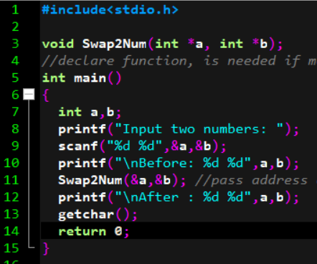

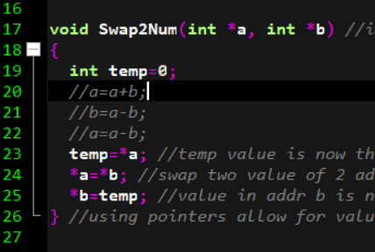

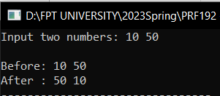

**Ex4 ( 2 marks) :** Print out the minimum and the maximum digits of a nonnegative integer integer.

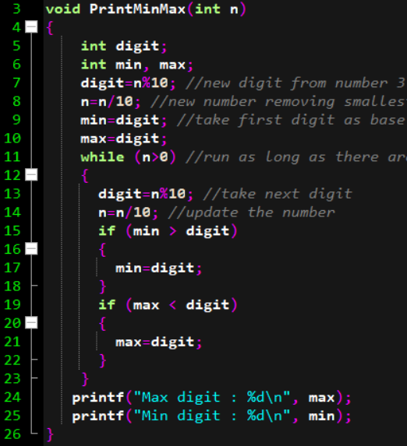

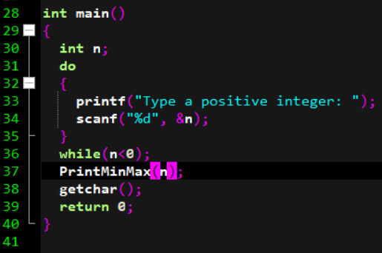

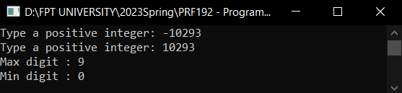

**Ex5 ( 2 marks) :** Write a C program to print the first n prime numbers.

